**CS 663 – Assignment 1 – Part 2**

1. 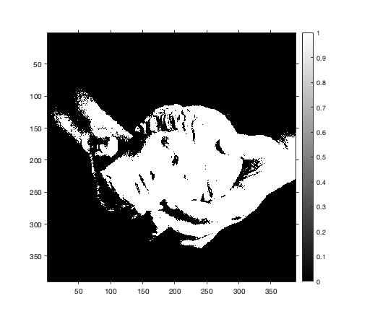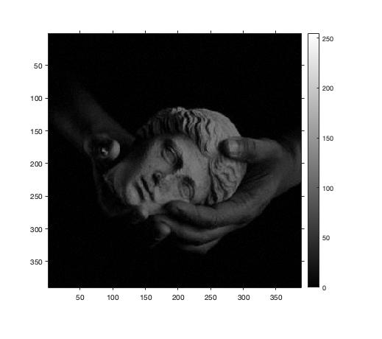**Foreground Mask**

Original Image Binary Mask

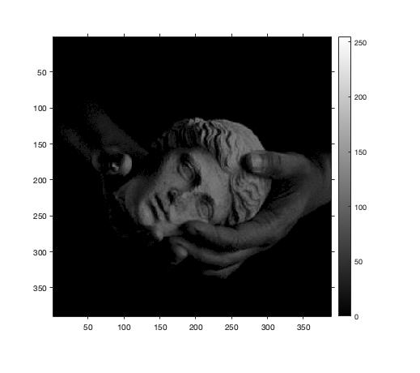  
  
  
  
  
  
  
  
  
  
  
  
  
  
  
  
  
  
 Masked Image

**(b) Linear Contrast Stretching**

Pseudo Code for Linear Contrast Stretching:

|  |
| --- |
| for each channel: |
| maxvalue = max of all pixel intensities for the channel |
| minvalue = min of all pixel intensities for the channel |
| outputpixels = (inputpixels - minvalue) / (maxvalue - minvalue) |

**Image 1:**

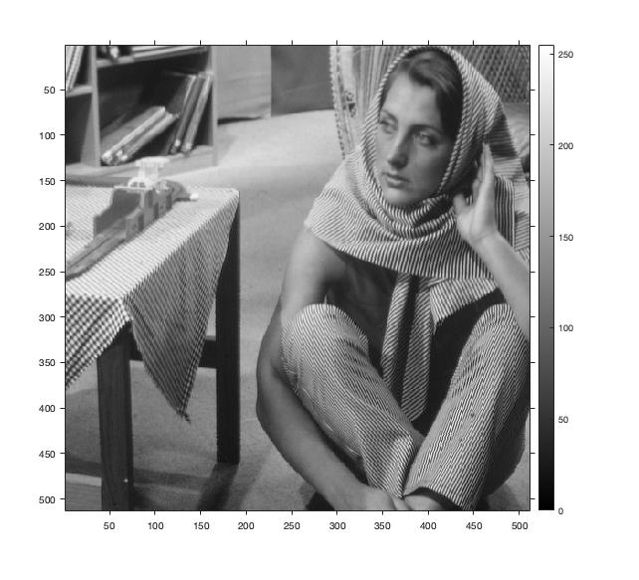 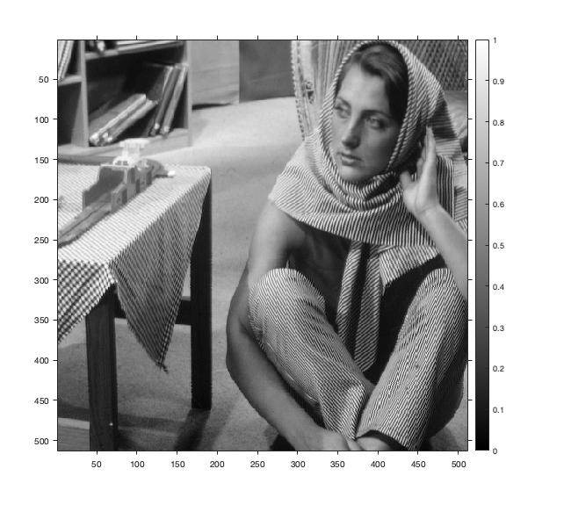

Original Linear Contrast Stretched

**Image 2:**

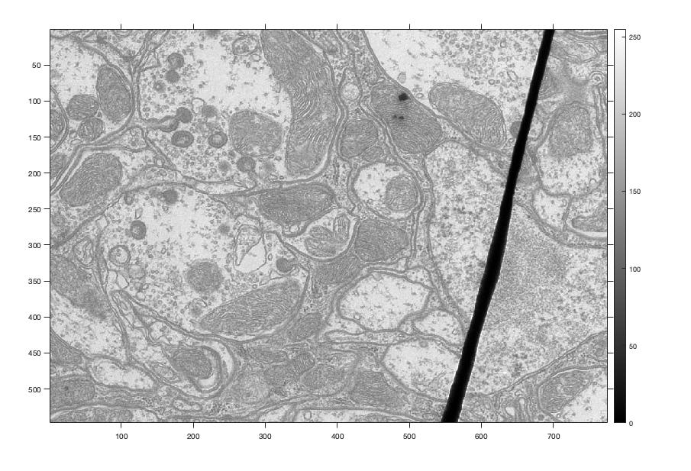 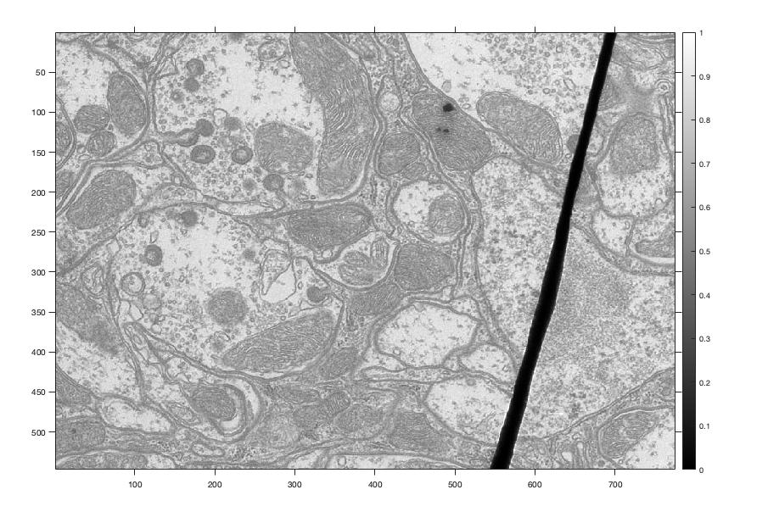

Original Linear Contrast Stretched

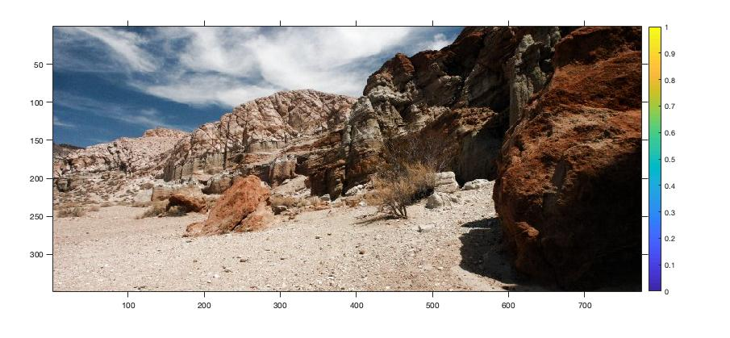**Image 3:**

Original

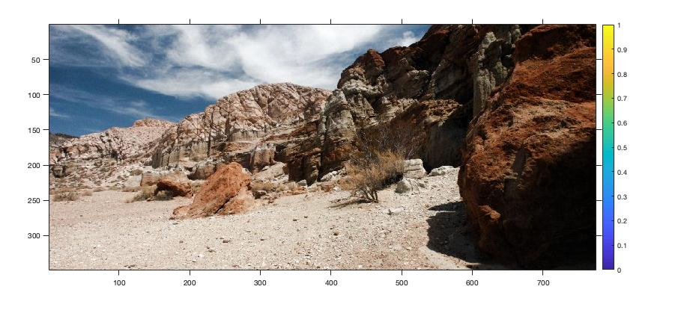

Linear Contrast Stretched

**Image 5:**

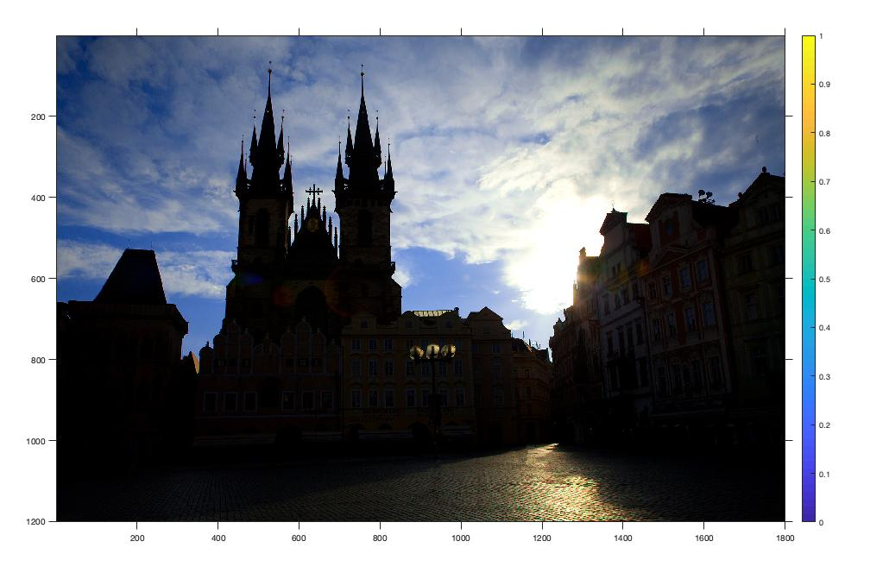 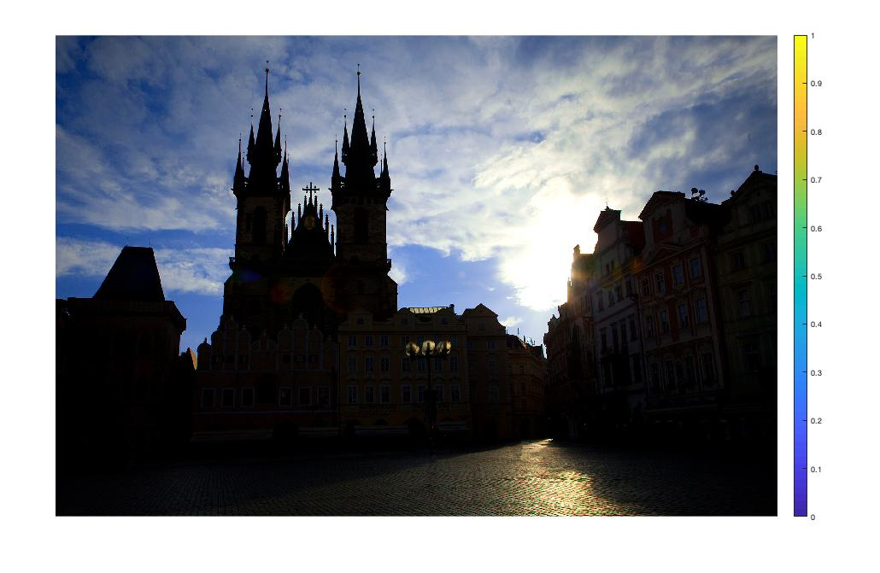

Original Linear Contrast Stretched

Observation for 5: Linear Contrast Stretching isn’t effective here because original image has intensities covering nearly the whole range. So linearly stretching won’t change the image much.

**Image 6:**

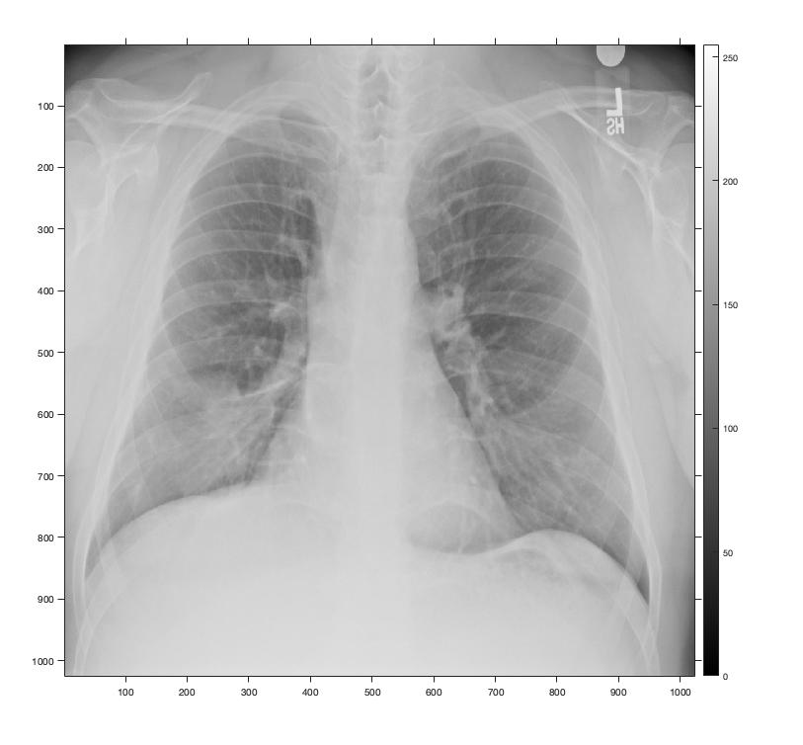 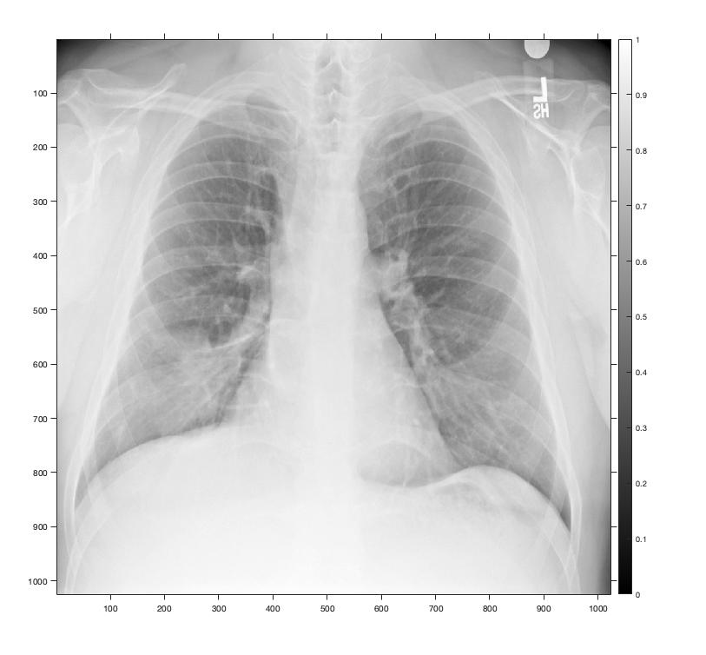

Original Linear Contrast Stretched

**Image 7 (masked):**

 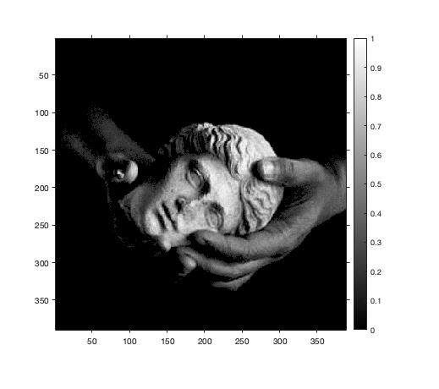

Original Linear Contrast Stretched

**(c) Histogram Equalization (HE)**

**Image 1:**

 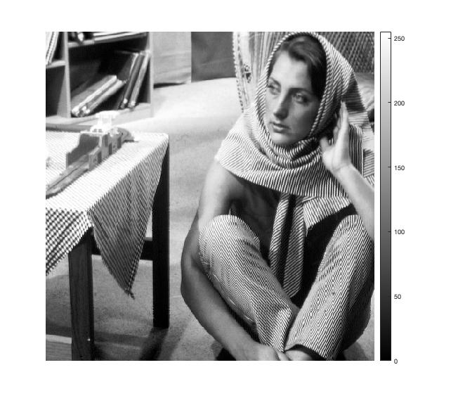

Original Histogram Equalized

**Image 2:**

 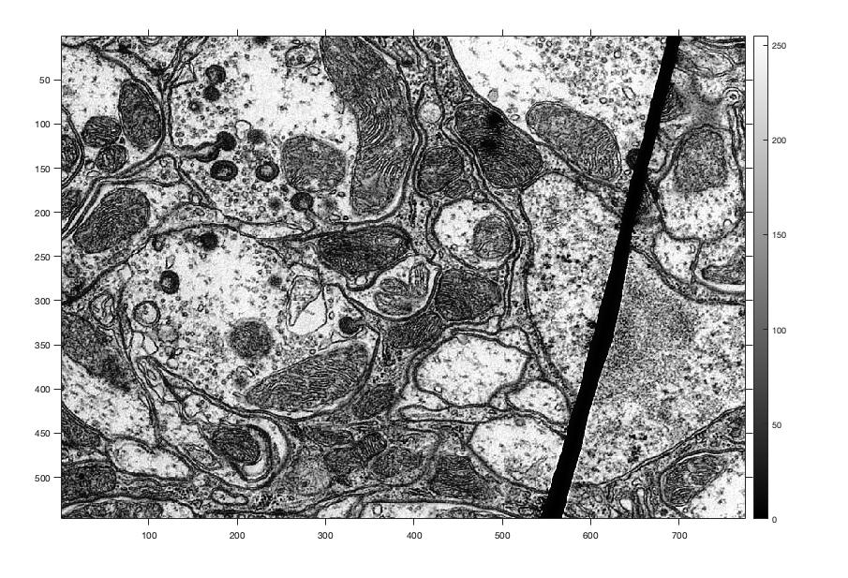

Original Histogram Equalized

**Image 3:**

Original

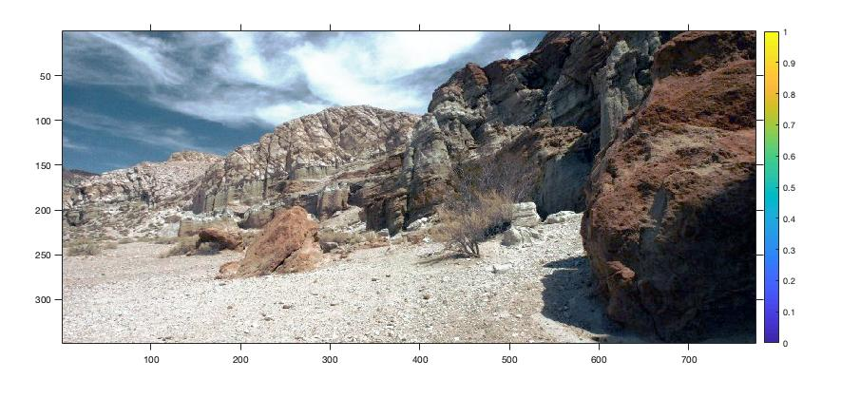

Histogram Equalized

**Image 5:**

 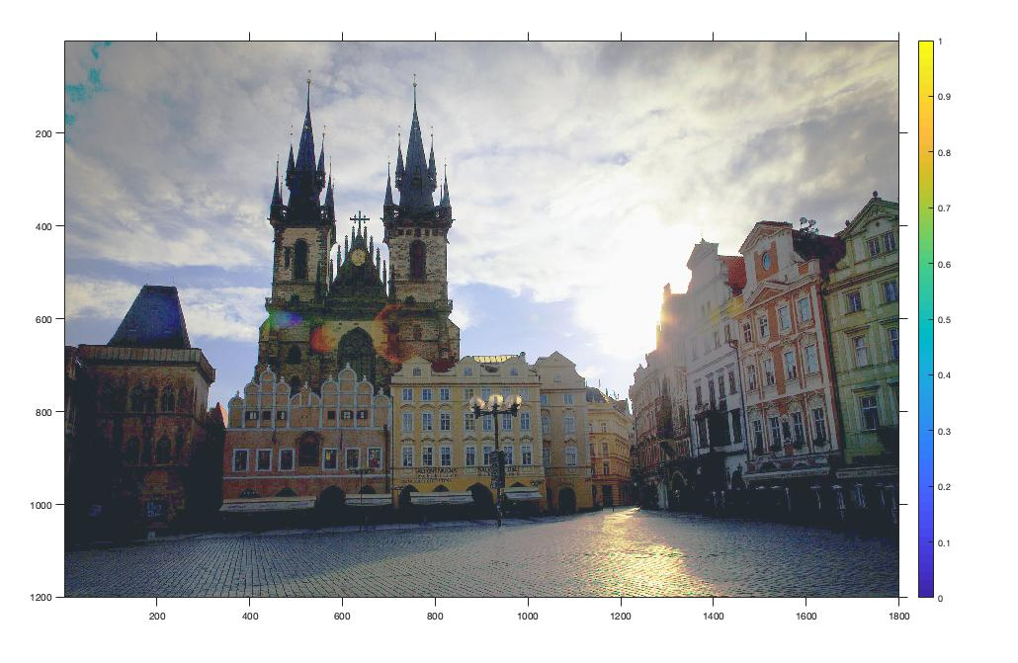

Original Histogram Equalized

Observation for 5: Histogram Equalization is effective here because original image doesn’t has intensities evenly distributed, which HE would correct out. So HE would be preferred over Linear Contrast Stretching.

**Image 6:**

 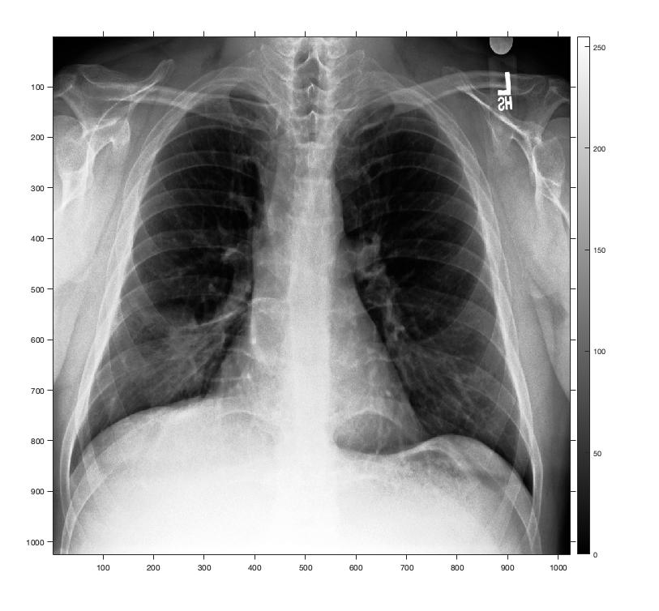

Original Histogram Equalized

**Image 7 (masked):**

 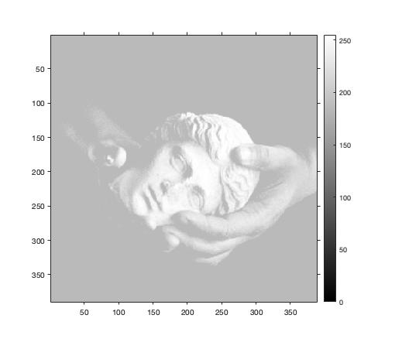

Original Histogram Equalized

**(d) Histogram Matching (HM)**

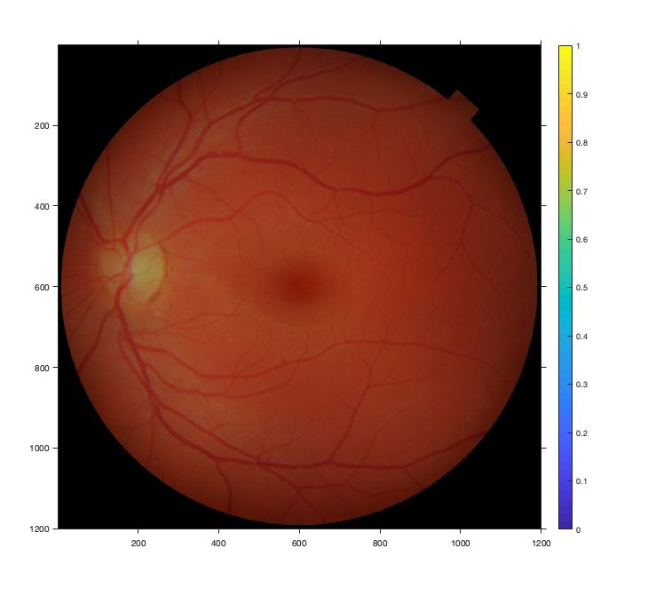

Original

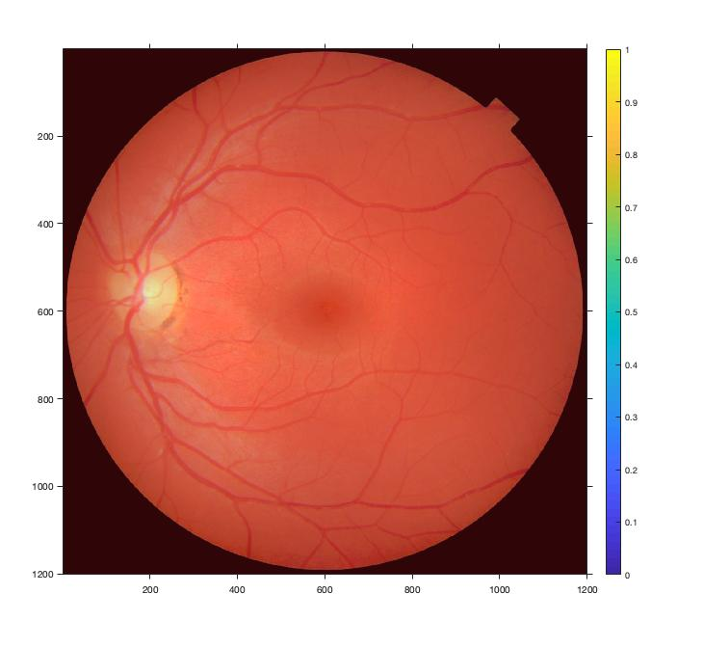

Histogram Matched

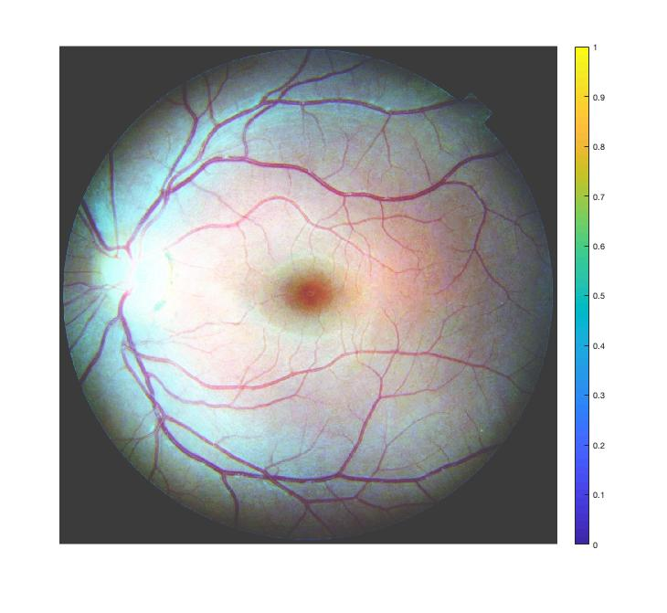

Histogram Equalized

**Observation**: Histogram Matching performs better (in preserving color) than Histogram Equalization.

Original image was mostly red, so histogram of red was nearly spread across the range but that of blue and green was not. Applying HE independently on each color made blue and green histogram to stretch out too across complete range. So pure red tend to change to white because of addition of blue and green.

While this problem doesn’t arise in HM since we give a reference image which was mostly red too. So blues and greens don’t stretch out as in HE. Hence red remains red.

**(e) Contrast-Limited Adaptive Histogram Equalization (CLAHE)**

|  |  |
| --- | --- |
| Original Image 1 | CLAHE with window=100, threshold=0.01 |
| Window=1000 (low contrast improvement) | Window=10 (excessive noise amplification) |
| window=100, threshold=0.005 (half) | |

Image 2

|  |  |
| --- | --- |
| Original Image 2 | CLAHE with window=100, threshold=0.01 |
| Window=1000 (low contrast improvement) | Window=10 (excessive noise amplification) |
| window=100, threshold=0.005 (half) | |

Image 3

|  |  |
| --- | --- |
| Original Image 3 | CLAHE with window=100, threshold=0.01 |
| Window=1000 (low contrast improvement) | Window=10 (excessive noise amplification) |
| window=100, threshold=0.005 (half) | |

Image 6

|  |  |
| --- | --- |
| Original Image 6 | CLAHE with window=100, threshold=0.01 |
| Window=1000 (low contrast improvement) | Window=10 (excessive noise amplification) |
| window=100, threshold=0.005 (half) | |